### Project Description

### 1.1 Project Overview

### This is a simulation zoo application based on AR technology. This interactive game is designed through AR technology to let children learn about animals in the experience. This app is more intuitive to feel the interaction with animals.

### 1.2 Project innovation

It can be applied to the zoo field, unlike the previous posters that only see static animal introductions, this application can let children know more about these animals.

## Project Analysis

### 2.1 Feasibility Analysis

### Use the knowledge learned in class and the mastery of Qualcomm technology to apply it to the zoo and daily life for children's interest and understanding of animals, so that the previously rigid pictures can be turned into videos to be more vivid.

### 2.2 Demand analysis

Let children learn about animal knowledge and interact with animals during interaction. Add fun to learning knowledge.

## Project Design

### 3.1 Design ideas

The first module is to introduce the basic information of animals, their names or breeds, etc.

In the second module, you can watch videos of animals to learn more about their stories.

The third module is to identify the models of animals, you can interact with them and let them make actions by clicking. You can also take pictures with them.

The fourth module is the camera function.

These modules are all pictures that can identify animals, display specific models and videos.

### 3.2 Design difficulties and key points

### Difficulty: The animation state machine and the realization of some codes.

### Focus: Mastery of Qualcomm technology.

### 3.3 Operational design

### Show the knowledge and stories of animals, and their models by scanning animal pictures. You can interact with them and take pictures with a mouse click.

### 3.4 interface design

The interface at the beginning and end of the game was designed, and the corresponding design drawings were also made when each animal was displayed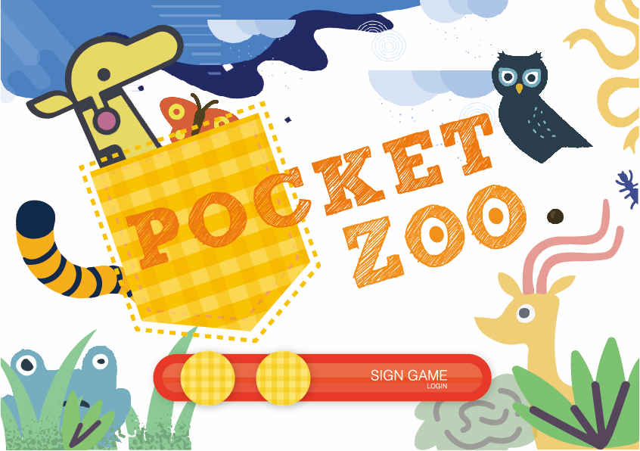

Game start interface

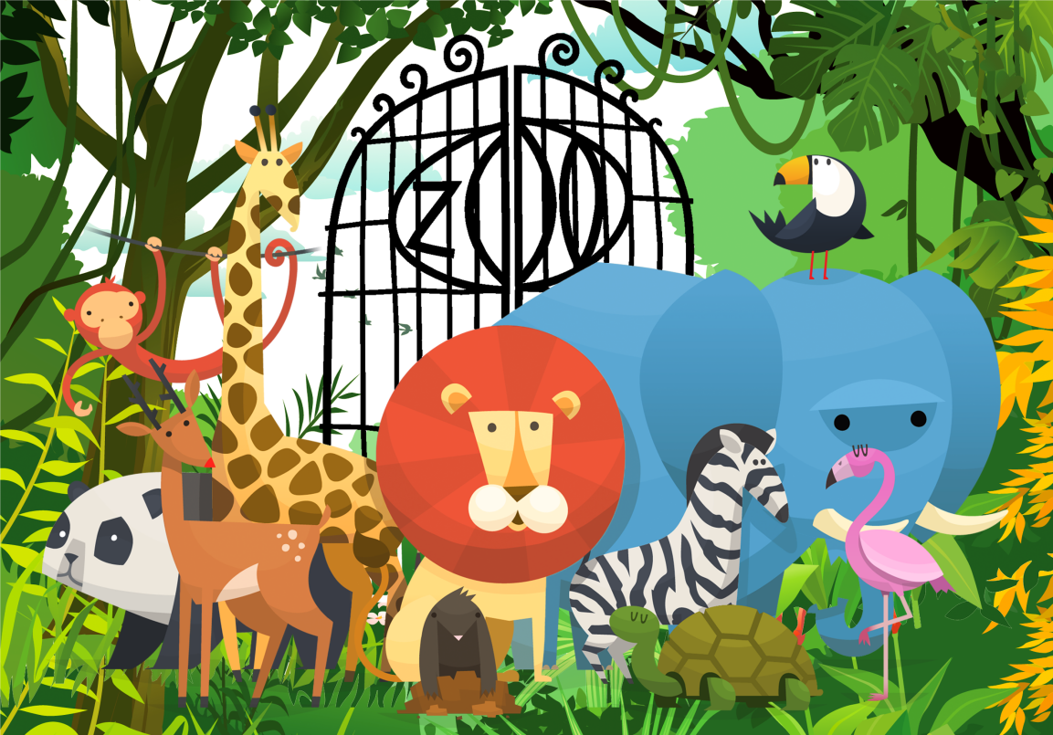

Game over interface

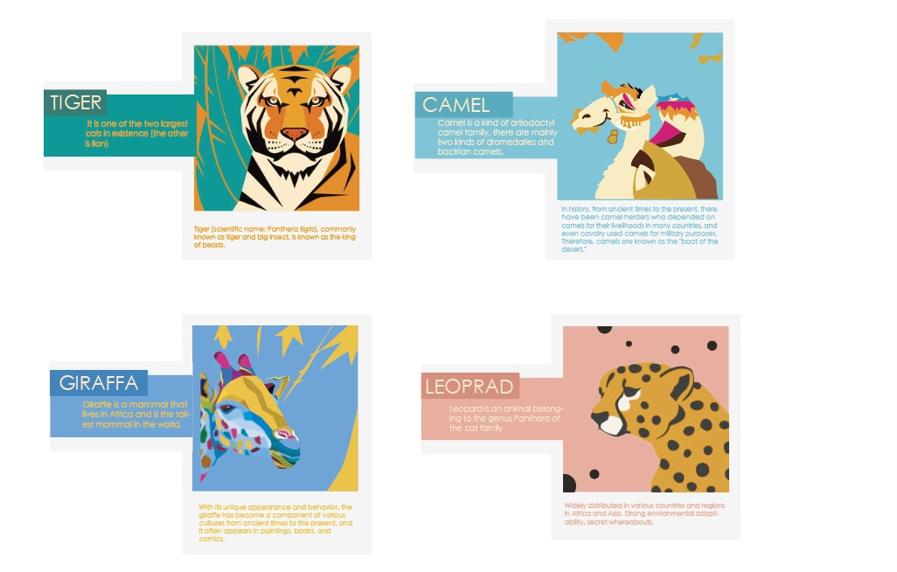

### Animal interface design

### 3.5 Sound design

With the background music of the zoo and the sound effects of animal models.

## Project realization

### 4.1 Function realization

1. Click the button to display the video through the scanned image, click the button again to pause the video, and click again to continue playing.

2. The character model appears through the scanned image, and by clicking the head, the animal can appear to stand, walk, etc.